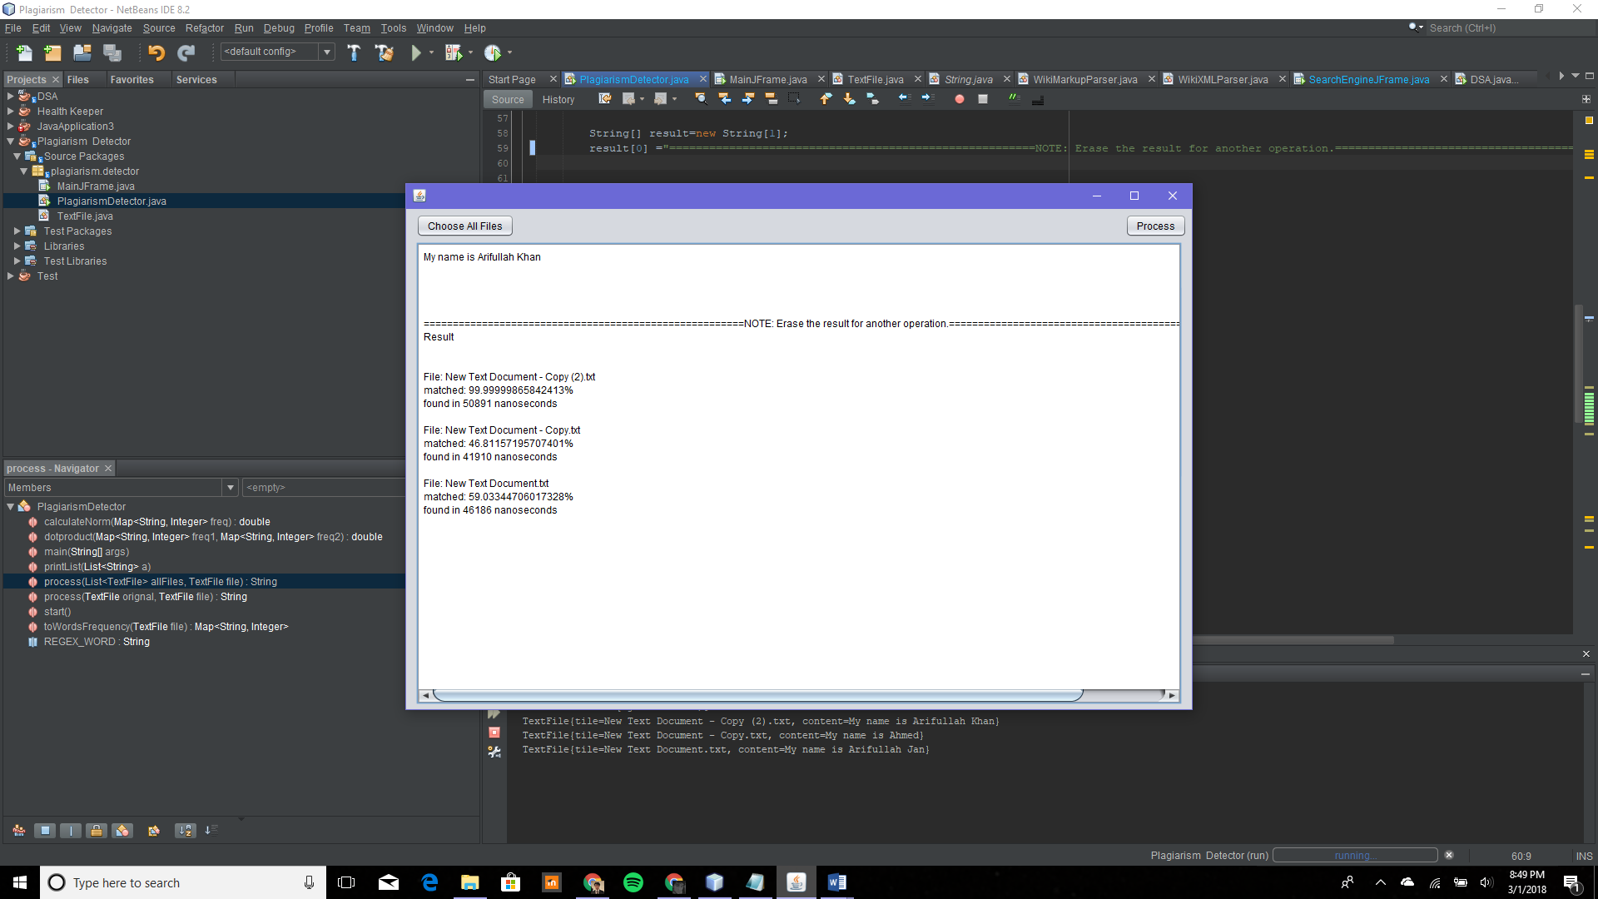

It works

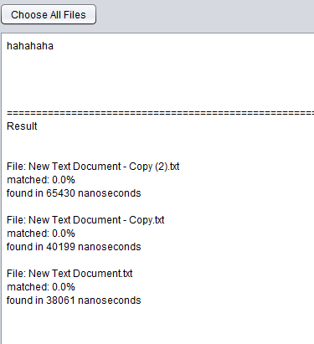

Step 1:

Select multiple original files.

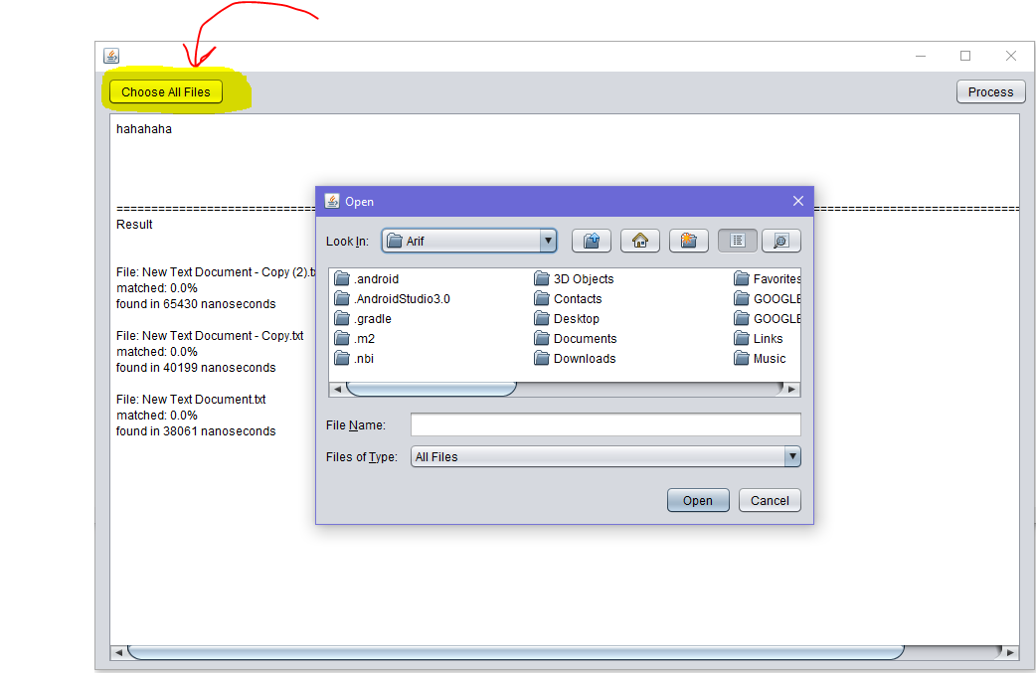

Step 2:

Paste the text in the text area and press process to check plagiarism.

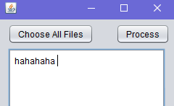

# Sample Result

File: New Text Document - Copy (2).txt

matched: 0.0%

found in 39344 nanoseconds

File: New Text Document - Copy.txt

matched: 0.0%

found in 24804 nanoseconds

File: New Text Document.txt

matched: 0.0%

found in 37633 nanoseconds